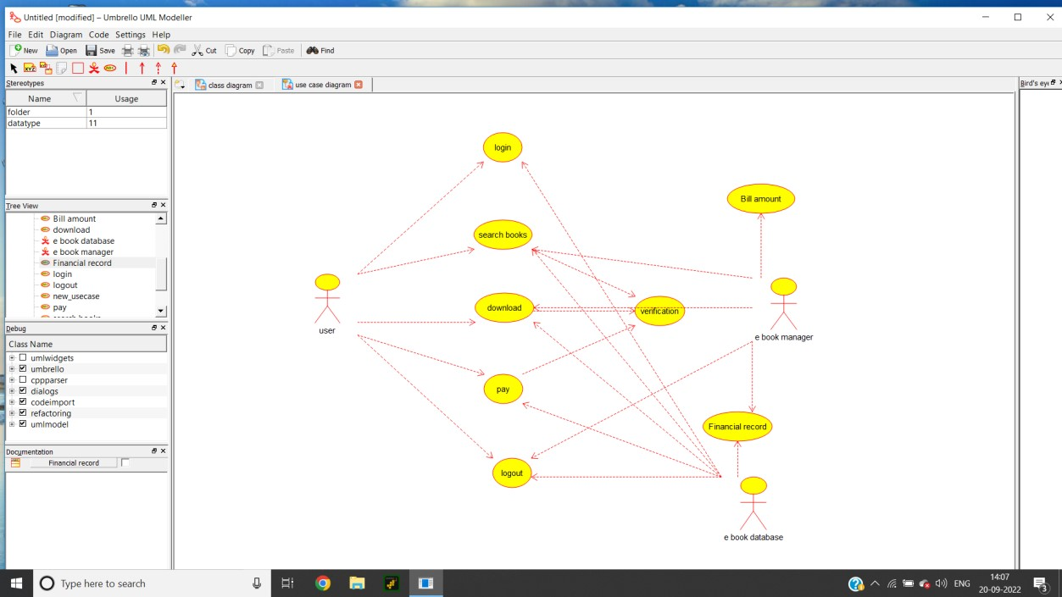

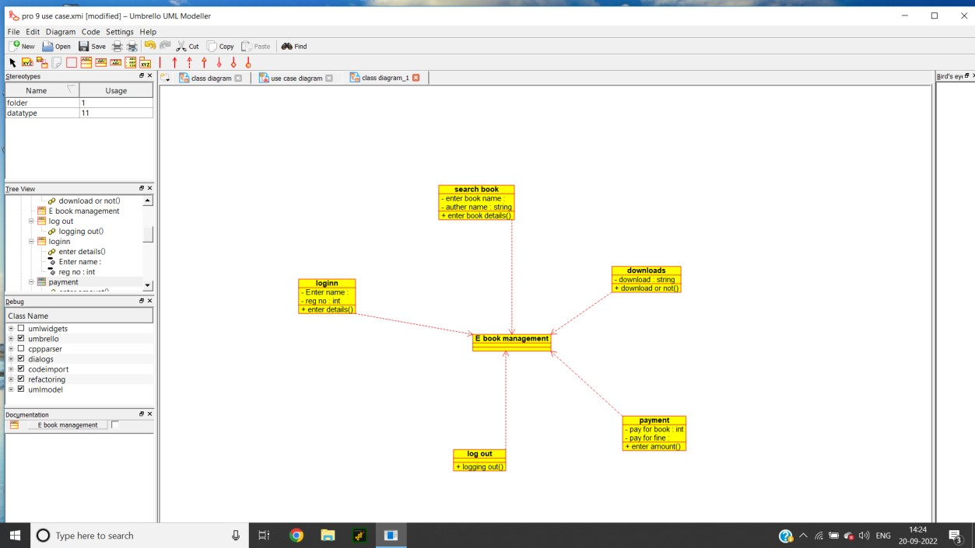

**Source Code:**

/**

* Class loginn */

public class loginn {

//

// Fields

// private void Enter_name; private int reg_no;

//

// Constructors //

public loginn () { };

//

// Methods

//

//

// Accessor methods

//

/**

* Set the value of Enter_name
* @param newVar the new value of Enter_name

*/

private void setEnter_name (void newVar) {

Enter_name = newVar;

}

/**

* Get the value of Enter_name
* @return the value of Enter_name

*/

private void getEnter_name () { return Enter_name;

}

/**

* Set the value of reg_no
* @param newVar the new value of reg_no

*/

private void setReg_no (int newVar) { reg_no = newVar;

}

/**

* Get the value of reg_no
* @return the value of reg_no

*/

private int getReg_no () { return reg_no;

}

//

// Other methods

//

/** */

public void enter_details()

{

}

}

/**

* Class search_book

*/

public class search_book {

//

// Fields

// private void enter_book_name; private String auther_name;

//

// Constructors //

public search_book () { };

//

// Methods

//

//

// Accessor methods

//

/**

* Set the value of enter_book_name
* @param newVar the new value of enter_book_name

*/

private void setEnter_book_name (void newVar) { enter_book_name = newVar;

}

/**

* Get the value of enter_book_name
* @return the value of enter_book_name

*/

private void getEnter_book_name () { return enter_book_name;

}

/**

* Set the value of auther_name * @param newVar the new value of auther_name

*/

private void setAuther_name (String newVar) { auther_name = newVar;

}

/**

* Get the value of auther_name
* @return the value of auther_name

*/

private String getAuther_name () { return auther_name;

}

//

// Other methods

//

/** */

public void enter_book_details()

{

}

}

/**

* Class downloads

*/

public class downloads {

//

// Fields

// private String download;

//

// Constructors //

public downloads () { };

//

// Methods

//

//

// Accessor methods

//

/**

* Set the value of download
* @param newVar the new value of download

*/

private void setDownload (String newVar) { download = newVar;

}

/**

* Get the value of download
* @return the value of download

*/

private String getDownload () { return download;

}

//

// Other methods

//

/** */

public void download_or_not()

{

}

}

/**

* Class payment */

public class payment {

//

// Fields

//

private int pay_for_book; private void pay_for_fine;

//

// Constructors //

public payment () { };

//

// Methods

//

//

// Accessor methods

//

/**

* Set the value of pay_for_book
* @param newVar the new value of pay_for_book

*/

private void setPay_for_book (int newVar) { pay_for_book = newVar;

}

/**

* Get the value of pay_for_book
* @return the value of pay_for_book

*/

private int getPay_for_book () { return pay_for_book;

}

/**

* Set the value of pay_for_fine
* @param newVar the new value of pay_for_fine

*/

private void setPay_for_fine (void newVar) { pay_for_fine = newVar;

}

/**

* Get the value of pay_for_fine
* @return the value of pay_for_fine

*/

private void getPay_for_fine () { return pay_for_fine;

}

//

// Other methods

//

/** */

public void enter_amount()

{

}

}

/**

* Class log_out

*/

public class log_out {

//

// Fields

//

//

// Constructors // public log_out () { };

//

// Methods

//

//

// Accessor methods

//

//

// Other methods

//

/** */ public void logging_out()

{

}

}